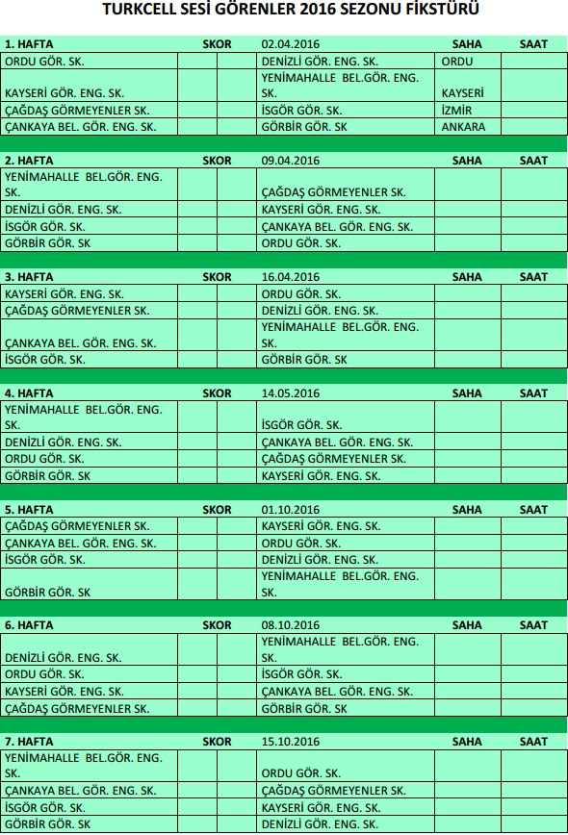
10.30
10.30
10.30
10.30
10.30
10.30
10.30
10.30
10.30
10.30
10.30
10.30
10.30
10.30
10.30
10.30
10.30
10.30
10.30
10.30
10.30
10.30
10.30
10.30
10.30
10.30
10.30
10.30
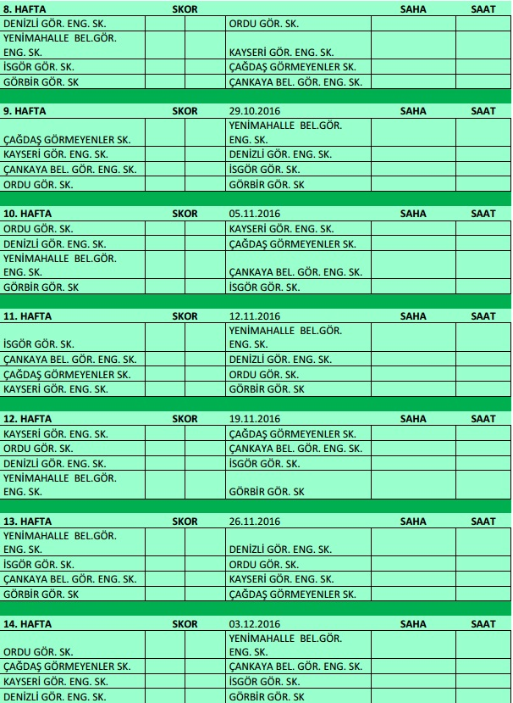
30.
22.10.2016
10.30
10.30
10.30
10.30
10.30
10.30
10.30
10.30
10.30
10.30
10.30
10.30
10.30
10.30
10.30
10.30
10.30
10.30
10.30
10.30
10.30
10.30
10.30
10.30
10.30
10.30
10.30
10.30

